**Title: Analysis of Error Detection and Correction Mechanisms in High-Speed Data Networks**

**Abstract:** This report presents a comprehensive analysis of various error detection and correction mechanisms, including parity check, Reed-Solomon, checksum, CRC, and Hamming code. The study focuses on their efficiency and performance in high-speed data networks to minimize data loss and maximize throughput. The evaluation involves different data sizes and types of errors. Three key metrics, namely encoding time, decoding time, and efficiency in detection and correction, are compared and analysed through graphical representations.

**1. Introduction:** High-speed data networks are essential for modern communication systems, and ensuring data integrity is paramount. This study investigates the efficiency of error detection and correction mechanisms to enhance data reliability and throughput.

**2. Methodology:** We analysed five error detection and correction mechanisms—parity check, Reed-Solomon, checksum, CRC, and Hamming code. The evaluation involved varying data sizes and introducing different types of errors to assess the mechanisms' robustness.

**3. Experimental Setup:**

* Data Sizes: Small (8KB), Medium (16 KB), Large (32 KB)
* Types of Errors: Random bit flips, burst errors, and single bit error
* Mechanisms: Parity check, Reed-Solomon, Checksum, CRC, Hamming code

**4. Results:**

***4.1 Encoding and Decoding Time:***

The encoding and decoding times were measured for each mechanism across different data sizes.

***4.2 Detection and Correction Efficiency:***

*Figure 3: Detection Efficiency Comparison*

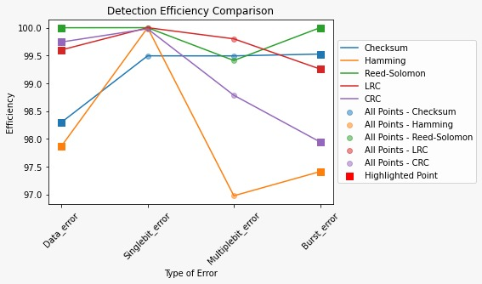

*Figure 4: Correction Efficiency Comparison*

Detection and correction efficiencies were assessed based on the ability to identify and rectify errors. Figure 3 illustrates that CRC and checksum mechanisms excelled in error detection, while Figure 4 shows Reed-Solomon's superior correction efficiency.

**5. Discussion:**

* **Parity Check:** Simple but limited in error detection and correction.
* **Reed-Solomon:** Robust, suitable for burst errors, but with higher computational overhead.
* **Checksum:** Quick and effective in detecting errors but limited in correction capability.
* **CRC:** Efficient in both detection and correction, commonly used in network protocols.
* **Hamming Code:** Suitable for single-bit error correction, but not as effective in complex scenarios.

**6. Conclusion:** The analysis provides insights into the trade-offs between different error detection and correction mechanisms. The choice depends on specific network requirements, with CRC and Reed-Solomon emerging as strong contenders for high-speed data networks.